Modern College of Arts, Science and Commerce, Pune-05

Department of Statistics

M.Sc. II

Date: 7-12-21

Practical No. 4

Practical title: Fitting of ARMA Non seasonal models

Q.1 Read the data file ___Apph.tsm______________ in ITSM. Fit the ARMA model.

Q.2 Read the data file ______Births___________. Fit the SARIMA model. The data Births contains monthly no. of births from 1946 to 1959.

Check if there is trend, seasonality is present or not, also fit the model without trend, without seasonality and without both trend & seasonality.

Q.1) Read the data file ___Apph.tsm______________ in ITSM. Fit the ARMA model.

> library(forecast)

> library(tseries)

a=(apph)

> a=ts(apph)

> a

Time Series:

Start = 1

End = 64

Frequency = 1

V1

[1,] 37123

[2,] 34712

.

.

.

[61,] 21534

[62,] 17857

[63,] 21788

[64,] 33008

> plot.ts(a)

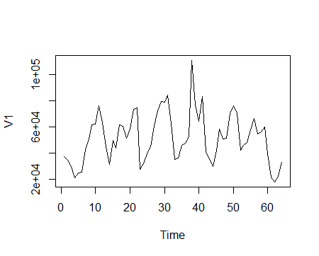

Interpretation: The data values are rise and fall over the same time period hence we say that there is cyclical variation present in the data.

> acf(a,type="correlation")

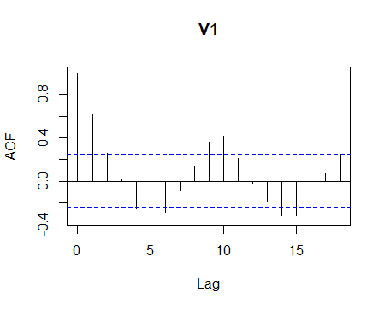

> acf(a,type="partial")

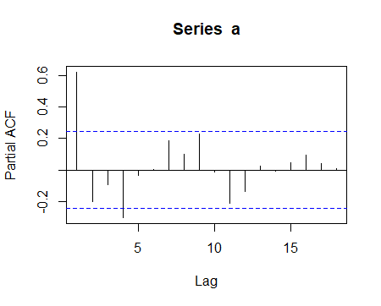

Interpretation: ACF and PACF shows slow decay hence ARMA (pq) model would be appropriate.

> adf.test(ts,alternative = "stationary")

Augmented Dickey-Fuller Test

data: ts

Dickey-Fuller = -4.8138, Lag order = 3, p-value = 0.01

Alternative hypothesis: stationary

H0: Time series is not stationary.

V/s H1: Time series is stationary.

Here p-value=0.01 <0.05 hence we reject H0. Hence we conclude that the given time series is stationary.

> auto.arima(a)

Series: a

ARIMA(1,0,0) with non-zero mean

Coefficients:

ar1 mean

0.6269 50736.05

s.e. 0.0966 4778.44

sigma^2 estimated as 220059069: log likelihood=-704.75

AIC=1415.49 AICc=1415.89 BIC=1421.97

Hence Model is: Xt + 0.6269 Xt-1 = Zt

Q.2) Read the data file ______Births___________. Fit the SARIMA model. The data Births contains monthly no. of births from 1946 to 1959.

Check if there is trend, seasonality is present or not, also fit the model without trend, without seasonality and without both trend & seasonality.

d=scan(‘clipboard’)

> library(tseries)

> library(forecast)

> d<-ts(Births,frequency =12, start=c(1946,1))

> plot.ts(d)

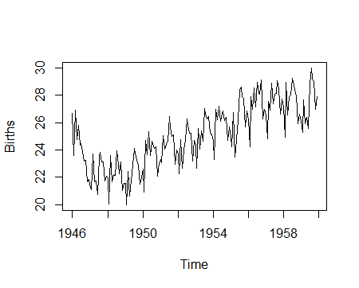

Interpretation: From the graph we can say that additive seasonality with trend is present in the data.

> acf(d,type="correlation")

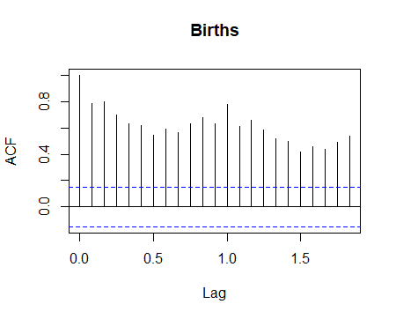

> acf(d,type="partial")

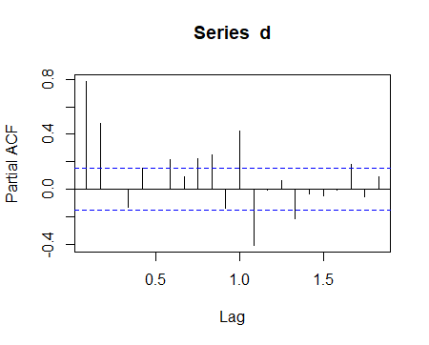

Interpretation: From that Partial and ACF plot we can say that ARMA model would be the appropriate fit.

> dcomp<-decompose(d)

> plot(dcomp)

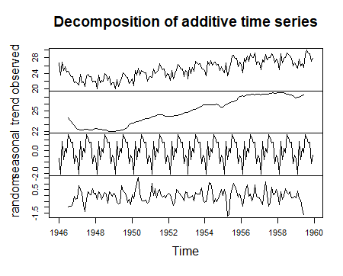

> auto.arima(d)

Series: d

ARIMA(2,1,2)(1,1,1)[12]

Coefficients:

ar1 ar2 ma1 ma2 sar1 sma1

0.6539 -0.4540 -0.7255 0.2532 -0.2427 -0.8451

s.e. 0.3004 0.2429 0.3228 0.2879 0.0985 0.0995

sigma^2 estimated as 0.4076: log likelihood=-157.45

AIC=328.91 AICc=329.67 BIC=350.21

> adf.test(d,alternative="stationary")

Augmented Dickey-Fuller Test

data: d

Dickey-Fuller = -5.9547, Lag order = 5, p-value = 0.01

alternative hypothesis: stationary

Warning message:

In adf.test(d, alternative = "stationary") :

p-value smaller than printed p-value

H0: Time series is not stationary.

V/s H1: Time series is stationary.

Here p-value=0.01 <0.05 hence we reject H0. Hence we conclude that the given time series is stationary.

> dadj1<-d-dcomp$trend

> auto.arima(dadj1)

Series: dadj1

ARIMA(2,0,1)(1,1,2)[12]

Coefficients:

ar1 ar2 ma1 sar1 sma1 sma2

1.2368 -0.6185 -0.8804 0.3534 -1.5505 0.7591

s.e. 0.0833 0.0705 0.0739 0.1925 0.2227 0.2136

sigma^2 estimated as 0.2192: log likelihood=-105.64

AIC=225.27 AICc=226.1 BIC=246.06

> dadj2<-d-dcomp$seasonal

> auto.arima(dadj2)

Series: dadj2

ARIMA(2,1,1)(1,0,2)[12] with drift

Coefficients:

ar1 ar2 ma1 sar1 sma1 sma2 drift

0.3894 -0.2033 -0.4471 -0.1050 -0.2195 -0.1200 0.0192

s.e. 0.2227 0.0843 0.2248 0.6952 0.6989 0.2087 0.0195

sigma^2 estimated as 0.336: log likelihood=-143.28

AIC=302.56 AICc=303.47 BIC=327.5

> dadj3<-d-dcomp$trend-dcomp$seasonal

> auto.arima(dadj3)

Series: dadj3

ARIMA(0,0,1)(1,0,2)[12] with zero mean

Coefficients:

ma1 sar1 sma1 sma2

0.4884 -0.1260 -0.2079 -0.1603

s.e. 0.0645 0.5248 0.5255 0.1623

sigma^2 estimated as 0.2204: log likelihood=-102.56

AIC=215.12 AICc=215.52 BIC=230.37

> plot.ts(dadj3)

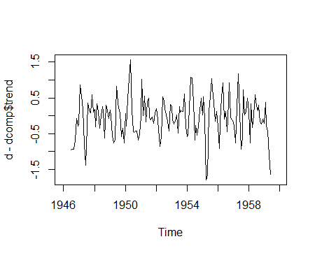

Interpretation: From the above graph we can say that seasonality and trend are remove from the data.